**BLOCKCHAIN IN AGRICULTURAL SUPPLY CHAIN**

**A PROJECT REPORT**

***Submitted by***

**Purushothaman P – 3122215002082**

**Karunagaran R - 3122215002046**

***in partial fulfilment for the award of the degree of***

**BACHELOR OF TECHNOLOGY IN**

**INFORMATION TECHNOLOGY**

**DEPARTMENT OF INFORMATION TECHNOLOGY**

**Sri Sivasubramaniya Nadar College of Engineering**

**(An Autonomous Institution, Affiliated to Anna University) Rajiv Gandhi Salai (OMR), Kalavakkam – 603 110 MAY 2025**

# Sri Sivasubramaniya Nadar College of Engineering (An Autonomous Institution, Affiliated to Anna University)

**BONAFIDE CERTIFICATE**

Certified that this project titled “**BLOCKCHAIN IN AGRICULTURAL SUPPLY CHAIN**” is the Bonafide work of **Purushothaman P (3122215002082) and Karunagaran R (3122215002046)** who carried out the work under my supervision.

Certified further that to the best of my knowledge, the work reported herein does not form part of any other thesis or dissertation on the basis of which a degree or award was conferred on an earlier occasion on this or any other candidate.

**Dr. A. Shahina Dr. N. Sripriya**

Professor and HoD Associate Professor

Department of Information Technology

Department of Information Technology

SSN College of Engineering SSN College of Engineering

Kalavakkam – 603 110 Kalavakkam – 603 110

Submitted for project viva-voce examination held on

**EXTERNAL EXAMINER INTERNAL EXAMINER**

# ABSTRACT

This project puts forward a tailor-made blockchain platform that is intended to optimize farm supply chains by cutting out intermediaries and directly linking farmers to consumers and retailers. We use a Proof of Quality (PoQ) consensus algorithm that pays farmers in terms of pre-specified quality measures, thus rewarding the cultivation of high-quality crops. The platform incorporates IoT sensors to monitor and store data regarding crop status, ensuring transparency and traceability. Through the creation of trust and transparency, our solution can potentially redefine the agricultural supply chain landscape.

Quality assessment is also complemented by using statistical metrics such as the Mahalanobis distance to detect anomalies with strong accuracy across several correlated sensor parameters All quality data are stored off-chain on IPFS in a secure manner, while only brief hash references are stored on the blockchain, thus maintaining data integrity while maintaining the system's lightness.

A committed peer-to-peer server enables secure real-time communication and dynamic assignment of validators based on reputation and capability, guaranteeing that only approved and high-quality produce is captured. Validators, such as cooperatives and food inspectors, are rewarded using a reputation-based rewards system and compensations directly from the network to ensure accuracy and accountability within the network. By cutting through bureaucratic processes and intermediary agents, this blockchain-powered strategy minimizes cost and allows farmers to obtain just pricing while maintaining consumer trust in transparent, data-backed quality guarantees. The suggested solution provides a sustainable, just, and immutable environment that makes agricultural supply chains modern, ensuring the general resilience and effectiveness of the industry.

# ACKNOWLEDGEMET

I thank **ALMIGHTY GOD** who gave me the wisdom to complete this Project. My sincere thanks to our beloved founder **Dr.SHIV NADAR, Chairman, HCL Technologies.** I also express my sincere thanks to **Ms. KALA VIJAYAKUMAR,** President, SSN Institution and our Principal **Dr. S. RADHA**, for all the help he has rendered during this course of study.

We are highly indebted to **Dr. A. Shahina, Head of the Department** for providing us with the opportunity and facilities to take up this project.

I am deeply obliged and indebted to the timeless help and guidance provided by **Dr. N. Sripriya, Associate Professor**, Department of Information Technology and also express my heartfelt thanks for making this project a great success.

I also thank all the faculty of the Department of Information Technology for their kind advice, support and encouragement and last but not the least I thank my parents and my friend for their moral support and valuable help.

# TABLE OF CONTENTS

|  |  |  |
| --- | --- | --- |
| **CHAPTER NO** | **TITLE** | **PAGE NO** |
|  | **ABSTRACT** | **iv** |
|  | **LIST OF TABLES** | **vii** |
|  | **LIST OF FIGURES** | **viii** |
| **1** | **INTRODUCTION** | 1 |
|  | 1.1 OVERVIEW | 1 |
|  | 1.2 MOTIVATION AND BACKGROUND | 1 |
| **2** | **LITERATURE SURVEY** | **3** |
| **3** | **PROPOSED METHODOLOGY** | **9** |
|  | 3.1 CREATION OF OWN BLOCKCHAIN | 9 |
|  | 3.2 PROOF OF QUALITY CONSENSUS MECHANISM(POQ) | 9 |
|  | 3.3 DIRECT FARMER-CONSUMER INTERACTION | 10 |
|  | 3.4 FOOD PRODUCT VALIDATION BY INSPECTORS | 11 |
|  | 3.5 CONSUMER INTERACTION USING QR CODE | 11 |
|  | 3.6 INCENTIVIZING VALIDATORS | 12 |
|  | 3.7 |  |
| **4** | **WORKFLOW DIAGRAM** | **13** |
| **5** | **WORKFLOW EXPLANATION** | **15** |
| **6** | **ALGORITHM** | **18** |
| **7** | **COST ESTIMATION** | **22** |
| **8** | **ARCHITECTURE DIAGRAM** | **23** |
| **9** | **OUTPUT SCREENSHOTS** | **24** |
| **10** | **SOCIAL IMPACT AND SUSTAINABILTIY** | **27** |
| **11** | **CONCLUSION** | **28** |
| **12** | **REFERENCES** | **29** |

|  |  |  |
| --- | --- | --- |
| FIGURE NO | DESCRIPTION | PAGE NO. |
| Figure 4.1 | Showing Workflow diagram of Blockchain |  |
| Figure 4.2 | Showing Workflow diagram of Customers |  |
| Figure 4.3 | Showing Workflow System of Blockchain |  |
| Figure 8.1 | Showing Architectural diagram |  |
| Figure 9.1 | Showing Output of Farmer Home Page-DashBoard |  |
| Figure 9.2 | Showing Output of Farmer Dashboard - Submit Produce |  |
| Figure 9.3 | Showing Output of Validator Dashboard |  |
| Figure 9.4 | Showing Output of Transactions For Validation. |  |
| Figure 9.5 | Showing Output of Blocks Page |  |
| Figure 9.6 | Showing Output of Blockchain Dashboard |  |
| Figure 9.7 | Showing Output of Merkle Tree |  |

**LIST OF FIGURES**

|  |  |  |
| --- | --- | --- |
| **TABLE NO** | **DESCRIPTION** | **PAGE NO.** |
| Table 7.1 | COST ESTIMATION |  |

**LIST OF TABLES**

# CHAPTER – 1 INTRODUCTION

# Overview

The agricultural sector has been the cornerstone of global economies, providing sustenance, employment, and raw materials across various industries. Despite its critical role, agriculture remains one of the least digitized sectors, often plagued by inefficiencies, lack of transparency, and inequitable distribution of resources. Traditional agricultural supply chains involve numerous intermediaries, leading to inflated costs, prolonged delays, and diminished profits for farmers—especially small- scale and independent producers.

Blockchain technology, with its core principles of decentralization, immutability, transparency, and security, is emerging as a transformative solution to these challenges. Originally designed for cryptocurrencies like Bitcoin, blockchain has demonstrated its potential to revolutionize industries far beyond finance, including agriculture. By recording every step of the supply chain—from farm to table—in a transparent and tamper-proof manner, blockchain technology paves the way for fairer, more efficient agricultural practices.

# Motivation and Background

Traditional agricultural supply chains often fail to meet the evolving demands of modern consumers, who prioritize quality, traceability, and sustainability in the products they purchase. This lack of transparency reduces consumer trust and leaves farmers disconnected from their end markets. Additionally, systemic inefficiencies disproportionately affect small-scale farmers, limiting their profits and discouraging sustainable practices.

Blockchain presents an opportunity to address these issues by introducing transparency, eliminating intermediaries, and ensuring equitable resource distribution. For farmers, blockchain fosters direct interactions with retailers and consumers, ensuring fair pricing and empowering them with real-time market insights. Consumers benefit from blockchain's ability to verify the origin, quality, and safety of agricultural products, promoting trust in the supply chain.

The integration of IoT sensors further enhances blockchain's utility in agriculture by providing real-time data on parameters such as soil health, weather conditions, and product freshness. Combined with smart contracts, blockchain can automate critical

processes like payments and compliance checks, streamlining operations while promoting sustainability.

This motivation underscores the importance of adopting blockchain in agriculture, particularly in regions where inefficiencies and systemic biases exacerbate farmers' challenges. By decentralizing control and ensuring equitable profit distribution, blockchain empowers small-scale farmers, aligns with global sustainability goals, and addresses food security concerns.

Through its ability to create a transparent, efficient, and equitable agricultural ecosystem, blockchain technology represents a pivotal advancement in modern farming, promising a sustainable and prosperous future for all stakeholders.

# CHAPTER 2 LITERATURE SURVEY

The comprehensive literature survey begins by reviewing studies on blockchain- based supply chain management, with particular attention to applications in agriculture.In[1], Agriledger, a blockchain-based solution, seeks to eliminate inefficiencies caused by intermediaries in agricultural transactions by providing transparent records and direct interactions between farmers and consumers. In this paper titled "Agriculture Supply Chain Management Based on Blockchain Architecture and Smart Contracts" introduces a blockchain framework that employs smart contracts to automate supply chain transactions, ensuring data integrity and security through a decentralized ledger. The blockchain's immutable nature ensures that agricultural data, such as environmental conditions gathered via IoT sensors, is securely stored, promoting transparency and traceability within the food supply chain.

In [2], Kim and Laskowski explore the application of blockchain technology in agriculture, focusing on sustainable solutions for food supplychain, financing, and local economies. They introduce blockchain-based systems that enhance transparency in food supply chains, allowing for real-time provenance tracking from farm to fork. Additionally, the research discusses smart contracts to automate transactions and mitigate corruption, particularly benefiting small farmers in developing regions. The study also highlights the role of blockchain in supporting sustainable agricultural practices, helping local cooperatives retain more value and improve market access. Overall, the blockchain framework is positioned as a transformative tool for modernizing agricultural supply chains.

In[3]highlights the limited digitalization in agriculture, which restricts the transfer and analysis of data between farms and other entities. The paper emphasizes that agriculture lags behind in adopting digital technologies, which could help improve data-driven decision-making and transparency. Blockchain technology is proposed as a solution to increase trust, ensure traceability, and enhance the quality and safety of agricultural commodities by providing a decentralized system to handle data. It can streamline the supply chain by reducing ambiguity and ensuring compliance with standards across the entire process, from production to market. The study explores the potential of blockchain to overcome these challenges, providing benefits such as improved accountability, efficiency, and security in agricultural supply chain management.

In[4], It Explores the use of technology, specifically text messaging, as a means to enhance meal planning and dietary intake in response to the increasing prevalence of obesity in the United States. The study focuses on the effectiveness of sending weekly nudges via a Facebook group to encourage individuals to plan and prepare meals at home rather than opting for fast food. The findings suggest that sending weekly nudges with specific dietary goals significantly impacts meal planning, leading to improved dietary intake. The results have implications not only for promoting healthier lifestyles but also for addressing motivation and needs in situations such as weight loss. Key terms include text messaging, nudges, meal planning, and dietary intake.

In [5],blockchain is presented as a transformative tool for agriculture, offering transparency and trust across the supply chain. The study emphasizes that blockchain can reduce transaction costs by eliminating intermediaries and ensuring secure peer- to-peer interactions between farmers and consumers. Moreover, smart contracts enable automated, timely payments based on real-time data from IoT devices, improving both efficiency and traceability. This decentralized approach also aids in addressing issues related to food quality, safety, and agricultural insurance by providing a reliable way to record and verify transactions. However, the integration of smallholder farmers into such ecosystems remains a challenge due to the need for technological infrastructure and access.

In [6],blockchain technology is explored as a promising solution for addressing traceability issues in agricultural supply chains. The study highlights the technology's key properties, such as reliability, transparency, and immutability, which make it effective for tracking the origins of food products. The growing need for such traceability systems stems from widespread concerns over harmful agricultural practices, like the excessive use of pesticides and fertilizers. Moreover, consumer demand for higher-quality products has driven interest in blockchain applications in agriculture. However, the research indicates that while blockchain shows great potential, its adoption is still in the early stages, with only a limited number of real- world implementations. Countries such as China, the United States, and Italy are leading in blockchain research for agriculture, but further efforts are needed to fully realize its benefits in the sector.

In[7], The exploration of blockchain technology within agri-food supply chains has gained significant attention in recent years, particularly regarding its potential to enhance trust, safety, and quality. Various studies have highlighted the effectiveness of blockchain in improving traceability, thereby addressing critical issues such as food safety and fraud in high-value products like wine and olive oil. For instance, recent research indicates that blockchain can facilitate transparent record-keeping,

allowing stakeholders to verify the authenticity and origin of products, which is essential in combating fraudulent practices. Additionally, literature reviews have pointed out the fragmented nature of existing research, suggesting a need for a cohesive understanding of blockchain's implementation across different regions and products. Notably, while the wine sector has seen substantial advancements in adopting blockchain solutions, the olive oil industry remains underexplored, indicating a gap in the literature. This body of work underscores the importance of integrating environmental and social considerations into the development of blockchain technologies, aiming not only to improve operational efficiency but also to promote sustainability and reduce waste in the agri-food supply chain.

In[8],Blockchain technology has emerged as a revolutionary tool in food and agricultural supply chains, addressing long-standing challenges of inefficiency, lack of transparency, and trust. By utilizing decentralized ledgers, it enhances traceability, ensuring that every step in the supply chain, from farm to fork, is verifiable and tamper-proof. Features like smart contracts automate transactions, reducing the reliance on intermediaries and ensuring timely payments, especially benefiting small-scale farmers. The integration of IoT devices with blockchain systems further strengthens this ecosystem by providing real-time data on environmental conditions, product quality, and logistics. This ensures compliance with safety standards and increases consumer trust in the food they consume.

In [9]: The disruptive technology of blockchain can offer a creative solution for product trackability in the food and agricultural supply chains. The technology can track and trace soybeans more effectively with a method that makes use of smart contracts and the Ethereum blockchain. The suggested solution improves efficiency and safety with high security, integrity, and reliability by doing away with the need for middlemen, a centralized authority that can be trusted, and transaction records. Furthermore, it simplifies the verification process for stakeholders by providing a tamper-proof ledger, ensuring the accuracy of data at every stage. This enhances not only operational transparency but also builds consumer confidence in the quality and safety of agricultural products.

Furthermore, blockchain-driven solutions like AgriBlockIoT and Ethereum-based frameworks have shown significant potential in promoting sustainability within supply chains. These technologies enable nutrient-related traceability, allowing consumers to make informed choices while supporting producers' efforts to maintain high-quality standards. Blockchain also fosters collaboration among stakeholders, from farmers and distributors to retailers and consumers, creating a more inclusive and equitable supply chain. Its application in high-value commodities, such as wine and olive oil, underscores its versatility and adaptability to various agriculturals.

In [10]: With a focus on aspects connected to safety, consumers have high expectations for food supply chains (FSC). However, the creation of reliable tracing techniques is hampered by the complexity and fragmentation of contemporary FSC networks. This project developed and tested a secure, distributed, and trust-less architecture for FSC traceability. By leveraging blockchain's decentralized nature, the system ensures seamless collaboration among multiple stakeholders, reducing delays and inconsistencies in data exchange. This approach addresses consumer concerns over food safety while fostering trust and accountability within the supply chain.

However, despite its immense potential, blockchain adoption in agriculture remains in its early stages, with challenges related to technological infrastructure, scalability, and accessibility. Many smallholder farmers face barriers in integrating blockchain solutions due to a lack of digital literacy and resources.

In [11]: Using the SWARA technique, agricultural specialists score the blockchain's component parts. This model was created to assess the blockchain's maturity and is evaluated using information gathered from a participant in the network of a business engaged in the agriculture sector. The study's findings indicate that the Internet of Things (IoT), smart contracts, and transaction records are the three most important features of the blockchain. Additionally, these features collectively contribute to enhanced operational efficiency by enabling real-time data collection, analysis, and automated decision-making. The research underscores the critical role of integrating these technologies for achieving scalable and sustainable solutions in agriculture.

As blockchain technology continues to evolve, its role in fostering sustainable, transparent, and efficient supply chains will only grow. The ongoing development of secure, distributed architectures and emerging trends, such as digitalization and stakeholder engagement, are paving the way for broader adoption. Innovative classification methodologies and models are also helping evaluate blockchain maturity, providing a roadmap for its integration across diverse sectors.

In [12]: This study intends to investigate how blockchain technology is being used in supply chain management systems, as well as its potential uses and emerging trends. Future orientation depends on four key issues: supply chain digitalization and integration, stakeholder engagement and collaboration, traceability and transparency, and shared frameworks on blockchain-based platforms. It highlights the importance of global collaboration to develop interoperable blockchain systems, addressing challenges in data standardization and governance. By bridging technological and operational gaps, these advancements could drive widespread adoption and innovation in blockchain applications across industries.

In [13]: It investigates the function that blockchain technology plays in managing a sustainable supply chain. For performing literature evaluations in different emerging technology focus areas, it suggests a reusable classification methodology called the Emerging Technology Literature Classification Level (ETLCL) structure. This methodology enables systematic assessment of blockchain applications in various contexts, ensuring comprehensive evaluation of their potential. The research emphasizes the necessity for future studies to focus on multi-sectoral use cases and the alignment of blockchain initiatives with global sustainability goals.

In [14]: Various application fields, including the social and legal sectors, the financial sector, supply chain networks, and smart property, use blockchain technology. With no requirement for a third trustworthy party, this ensures the integrity and immutability of data. The decentralized approach also reduces operational costs by streamlining processes and eliminating redundancies. Furthermore, blockchain's versatility in addressing complex challenges across these fields positions it as a cornerstone for future technological advancements.

In [15]: In agrifood supply chains (ASCs), consumers pay for the agricultural products that farmers produce. Consumers stress the significance of agri-food safety during this process, while producers anticipate higher revenues. Product traceability is a feature of the blockchain-based ASC framework, which also ensures decentralized confidentiality for the agri-food tracking data in ASCs. This framework fosters stronger connections between farmers and consumers, creating a transparent ecosystem that encourages fair pricing and equitable value distribution. It also enables compliance with regulatory standards, further safeguarding food safety and quality.

In [16]: This study's primary objective is to conduct a review of the literature on blockchain claims in agricultural supply chains, with a particular emphasis on nutrient-related traceability difficulties. The connection between nutrition traceability and blockchain in the agricultural farming system is examined in this research. By integrating blockchain with IoT and data analytics, the study envisions a future where precise nutrient data is available to consumers, empowering them to make informed dietary choices. This approach also supports efforts to combat malnutrition and promote sustainable agricultural practices.

In [17]: AgriBlockIoT is a traceability solution built on the blockchain that connects data from IoT devices throughout the whole supply chain. They compared how Hyperledger and Ethereum were built and created a use case for tracking food from farm to table. According to the research, blockchain technology holds promise for developing an open food supply chain. The system's ability to integrate real-time data from diverse sources ensures transparency and accountability at every step. By

bridging technological gaps, it fosters collaboration among stakeholders, paving the way for an inclusive and efficient agricultural ecosystem.

In This paper[18] investigates the use of IoT and deep learning for real-time environmental monitoring and anomaly detection in multidimensional time series data for smart agriculture. As data loss, misrepresentation, and intricate correlations are the challenges faced, the proposed research employs a GAN-based anomaly detection model with an encoder–decoder architecture and an attention mechanism. A new method of calculating the reconstruction error through the use of point-wise difference and curve similarity enhances the accuracy of detection. Experimental outcomes on three smart agriculture datasets show better performance, having precision, recall, and F1-score as 0.9351, 0.9625, and 0.9482, respectively.

These related works explore the potential of blockchain across various sectors, with a specific focus on agriculture. Blockchain technology offers transparency, traceability, and security through decentralized peer-to-peer networks, addressing issues such as double-spending (Bitcoin, Nakamoto) and improving supply chain traceability in agriculture (Hang Xiong, Sandeep Kumar). Blockchain helps track the provenance of agricultural products, ensuring data integrity and promoting smart farming via IoT integration. Furthermore, smart contracts enable automated transactions and secure payments between farmers and consumers. However, the research notes that blockchain applications are still in their early stages, requiring further adoption to fully realize their benefits.

The integration of blockchain technology in food and agricultural supply chains offers transformative potential by enhancing transparency, traceability, and operational efficiency. By leveraging features such as smart contracts, IoT, and distributed ledgers, blockchain addresses critical challenges like food safety, stakeholder trust, and supply chain complexity. It eliminates intermediaries, reduces inefficiencies, and ensures the integrity of transaction records, creating a secure and reliable ecosystem. Studies and solutions like AgriBlockIoT and blockchain-based ASC frameworks demonstrate the feasibility of real-time tracking, nutrient traceability, and data-driven decision-making. As blockchain continues to evolve, its adoption across supply chains is expected to drive sustainability, foster global collaboration, and meet the growing demand for secure and transparent food systems. Future research and innovation in blockchain platforms will be key to overcoming existing limitations and achieving widespread adoption in agriculture and beyond.

In conclusion, blockchain technology represents a paradigm shift in managing food and agricultural supply chains, offering innovative solutions to longstanding challenges. It not only improves operational efficiency but also empowers stakeholders by ensuring accountability, reducing waste, and promoting sustainability. Future research and development efforts must focus on overcoming existing barriers, enabling widespread adoption, and maximizing the transformative impact of blockchain in agriculture and beyond. With continued investment and collaboration, blockchain holds the promise of reshaping global food systems for the better.

# CHAPTER 3

**Proposed Methodology and Architecture**

### Creation of our own Blockchain:

The foundation of this project is the development of a custom blockchain tailored to address the specific needs of agricultural supply chains. Unlike generic blockchain platforms, our custom blockchain will be optimized to facilitate seamless interactions among farmers, consumers, and retailers, ensuring decentralized traceability and transparency in every transaction. The blockchain will maintain detailed records of essential product data, including origin, quality metrics, and validation status. These records will be immutable and tamper-proof, enhancing trust among stakeholders. By decentralizing data management, the system eliminates the reliance on intermediaries and central authorities, creating a transparent and equitable platform.

A custom blockchain will be developed to support seamless interactions between farmers, consumers, and retailers, ensuring decentralized traceability and transparency in every transaction. The blockchain will also store essential product data, such as origin, quality metrics, and validation status.

This blockchain is designed to handle large-scale data generated by IoT sensors and manual inspections, ensuring that all critical information about agricultural products is securely stored and easily accessible. Moreover, the blockchain will employ lightweight algorithms to ensure scalability and efficiency, making it accessible even in rural areas with limited computational resources. This approach ensures that farmers, regardless of their technological expertise or infrastructure, can participate in the system seamlessly.

### Proof of Quality(PoQ) Consensus Mechanism:

One of the standout features of the proposed system is the implementation of the **Proof of Quality (PoQ)** consensus mechanism. Unlike traditional consensus algorithms like Proof of Work (PoW) or Proof of Stake (PoS), PoQ is tailored to the agricultural context. This mechanism rewards farmers based on predefined quality metrics, such as freshness, organic certification, pesticide-free status, and nutrient content.

The system employs a PoQ consensus that rewards farmers based on predefined quality metrics .These metrics are validated through IoT sensor data and manual inspections. The quality score is determined using Mahalanobis Distance (MD) and Reconstruction Error (RE) from an autoencoder model.

QualityScore=MD+(RE×Scaling Factor)

* **Auto-Approve**: If Quality Score < 5
* **Needs Review**: If Quality Score < 10
* **Reject**: If Quality Score ≥ 10 or fraud detected

For instance, IoT sensors placed in farms can measure parameters such as soil quality, moisture levels, and temperature, which are then stored on the blockchain. Manual inspections by food inspectors add another layer of validation, ensuring that only high- quality produce enters the supply chain. Farmers who meet or exceed these quality benchmarks are rewarded, incentivizing them to adopt sustainable and high-quality farming practices

The PoQ mechanism fosters a competitive environment where quality is prioritized over quantity. By linking rewards directly to quality metrics, the system not only improves the standard of agricultural products but also enhances consumer trust. This ensures that the supply chain is populated with premium products, ultimately benefiting both consumers and farmers.

The blockchain will use a Proof of Quality (PoQ) consensus to reward farmers based on predefined quality metrics (such as freshness, organic certification, or pesticide-free produce). This mechanism ensures that only high-quality produce enters the supply chain.

### Direct Farmer-Consumer Interaction:

The elimination of intermediaries is a critical goal of the proposed system. In traditional agricultural supply chains, middlemen often exploit farmers by offering low prices for their produce while charging high prices to consumers. By enabling direct interaction between farmers and consumers, the blockchain platform ensures fair trade and transparency. Farmers can list their products directly on the platform, providing detailed information about the origin, quality, and certification status of their produce.

Consumers can access this information before making a purchase, fostering informed decision-making. Payments are processed directly between the parties, with all transactions recorded on the blockchain for transparency and accountability. This approach not only ensures that farmers receive fair compensation for their labor but also provides consumers with high-quality products at reasonable prices. By bypassing intermediaries, the system creates a more equitable and efficient agricultural ecosystem.

Notably, the platform will not use cryptotokens for transactions, opting instead for direct payment mechanisms. This decision reduces the complexity of the system and ensures that it is accessible to all stakeholders, including those unfamiliar with cryptocurrency. All payment records and interactions are securely stored on the blockchain, creating a reliable and auditable system.

Farmers and consumers will interact directly on the platform, bypassing middlemen, to ensure fair trade and traceability. Consumers will have access to product quality data, verified directly on the blockchain, promoting transparency in the buying process. Cryptotokens will not be used; payment mechanisms will focus on direct transactions, with all interactions recorded on the blockchain for transparency.

**3.4 Quality Verification Through IoT and Blockchain:**  
For verifiable quality assurance, the system will include IoT sensors for tracking environmental and production conditions. The sensors will capture real-time data like temperature, humidity, soil, and freshness levels and upload them to the InterPlanetary File System (IPFS) for storage off-chain. The IPFS hash alone will be stored on-chain, avoiding wasteful use of data and preserving data integrity and transparency. Food inspectors will also confirm the quality of produce by manual checks, with their findings being eternally documented on the blockchain, ensuring authenticity and trust.

**3.5 Dynamic Validator Assignment and Queue Management:** Transactions are automatically assigned to multiple validators based on their reputation and current queue capacity. This dynamic assignment ensures that one validator does not become a bottleneck, which improves the responsiveness and efficiency of the system. By load-balancing the validators, the system can process more transactions and still achieve high throughput. This approach also increases the fairness in task distribution, allowing validators to participate based on their capacity and reliability, ultimately enhancing the network's robustness and performance.

**3.6 Transaction Pool and Voting Mechanism:** The transaction pool is a holding space for submissions of produce until they are validated as necessary. Every transaction must be signed off on by at least 50% of validator assignments or an override from an AI to be finalized. This consensus-driven method ensures only transactions that satisfy quality requirements are put onto the blockchain. Collective decision-making with the voting mechanism makes the validation process more secure. It is also a form of deterrent to fraudulent behavior, since several validators are required to agree on whether a transaction is valid or not, thus protecting the system from possible manipulation.

**3.7 AI-Based Quality Check Fallback:** In situations where validator votes fall short of the threshold, a quality check by AI serves as insurance. It examines IoT sensor data and physical sample data to make the final judgment. Through this AI-based method, continuity of operations is ensured through a dependable backup to human validation. The AI system is able to recognize patterns and inconsistencies that human validators may miss, providing an unbiased analysis of produce quality. This increases the accuracy and dependability of the validation process so that only high-quality produce is certified.

**3.8 Integration with IPFS for Off-Chain Data Storage:** IoT sensor data and physical sample data are submitted to IPFS, and only their hash references are stored in transactions. Such an off-chain data storage mechanism lightens the data burden on the blockchain, and hence, the blockchain becomes lighter and more efficient. Through the use of IPFS, the system provides decentralized and tamper-proof storage of vital data, which can be checked at any point. Such integration provides improved data integrity and scalability so that the system can process large amounts of information without losing efficiency.

**3.9 Automatic Mining Trigger:** A background process routinely scans the transaction pool and automatically triggers mining in the presence of approved transactions. Automation eliminates much of the human intervention required, and it also speeds up the incorporation of valid transactions into the blockchain. Ongoing updates maintained by the system provide real-time synchronization and boost the efficiency of blockchain operations.

**3.10 Incentivization of Validators:** Validators such as food inspectors, cooperatives, and agricultural authorities are important in maintaining quality standards in the system. While cryptotokens will not be utilized for incentivization, validators will be incentivized through a reputation-based system. Their performance will be measured on the accuracy and integrity of their validations, with high-reputation validators having priority in transaction assignments and more influence in resolving disputes. This reputation-based incentive scheme guarantees that only the most trustworthy validators stay online.It ensures a high level of trust and accountability within the network.

**3.11 Merkle Tree Verification:** A Merkle tree is built from block hashes to ensure the integrity of the entire blockchain. The structure makes it easy to quickly check whether transactions in a block have been altered. The Merkle tree is able to manage large sets of transactions in an efficient way, offering a scalable solution to ensuring data integrity throughout the blockchain. This process not only improves security but also helps the system to process and verify transactions at scale.

**3.12 State Synchronization via Pub/Sub Mechanism:**A Pub/Sub system propagates updates to all nodes in real time, so all participants see the most recent state of the network. This mechanism encourages consistency and minimizes data inconsistency, allowing reliable communication in a distributed system. Through synchronized states between nodes, the system guarantees that all participants are able to make decisions.

### 3.13 Food Product Validation by Inspectors:

To ensure the highest standards of quality and safety, food inspectors will play a crucial role in the validation process. These inspectors will assess the quality of agricultural products through a combination of manual inspections and IoT-generated data. For example, IoT sensors can provide real-time data on storage conditions, such as temperature and humidity, while inspectors verify visual and physical quality attributes.

Inspection reports are recorded on the blockchain, adding an additional layer of authenticity and trust to the product’s history. This dual-layer validation process ensures that only products meeting strict quality standards are approved for sale. Moreover, by recording inspection results on the blockchain, the system creates a permanent and tamper-proof record of each product’s journey, from farm to table.

The integration of InterPlanetary File System (IPFS) ensures efficient storage and retrieval of IoT data. By decentralizing data storage, IPFS complements the blockchain, providing a scalable solution for handling the vast amount of data generated during inspections.

Food inspectors will validate the quality of produce based on both manual inspections and IoT data stored on IPFS. Their inspection reports are recorded on the blockchain, adding an additional layer of authenticity and trust to the product’s history. Successful validations will contribute to the approval of crops, ensuring high-quality standards.

### 3.14 Incentivizing Validators :

The success of the proposed system hinges on the active participation of validators, such as food inspectors and agricultural cooperatives. These validators are responsible for ensuring the quality and authenticity of agricultural products. To motivate them, the system incorporates a robust incentivization mechanism. While cryptotokens are not used, validators are rewarded through alternative means, such as:

3.14.1 Reputation systems that recognize and reward validators for their accuracy and integrity.

3.14.2Direct financial incentives based on the number and quality of validations performed.

The reputation system is particularly significant, as it fosters a culture of accountability and excellence among validators. High-performing validators gain recognition within the network, enhancing their credibility and trustworthiness. This approach ensures that the validation process is both rigorous and reliable, ultimately benefiting all stakeholders.

Validators such as food inspectors and agricultural cooperatives play a critical role in ensuring product quality. While cryptotokens are not used, these validators could be incentivized through reputation systems or direct rewards, based on the accuracy and integrity of their validations.

By leveraging blockchain technology, our system enhances trust in agricultural trade, reduces supply chain inefficiencies, and increases farmer profits. Initial results demonstrate improved traceability, reduced operational costs, and enhanced consumer confidence in product quality. With its ability to provide a transparent and equitable trading ecosystem, our solution has the potential to reshape the future of agriculture.

**3.15 Mahalanobis Distance for Quality Evaluation:**

To enhance the accuracy and reliability of quality assessment in our blockchain-based agricultural system, we propose integrating Mahalanobis Distance as a statistical measure to evaluate IoT sensor data against validator sample data. This method ensures a multidimensional and correlation-aware approach to quality verification.

The Mahalanobis Distance (MD) measures how far a given data point (farmer’s IoT sensor readings) deviates from a reference distribution (validator’s sample data) while considering correlations between different sensor parameters (temperature, humidity, light, etc.). Unlike Euclidean distance, MD accounts for interdependencies among variables, providing a more precise measure of deviation.

**3.15.1 Implementation in Our System**

1. **Data Collection**
   * IoT sensors capture real-time agricultural parameters (e.g., temperature, humidity, soil moisture).
   * Validators provide sample quality benchmarks for comparison.
2. **Calculation of Mahalanobis Distance**
   * Compute the **mean** and **covariance matrix** of the validator’s sample data.
   * Compare each new IoT data point against this distribution using:

D² = (x - μ)ᵀ Σ⁻¹ (x - μ)

* + Flag data points with a high MD as **potential anomalies**.

1. **Integration with Blockchain Validation**
   * If MD is within a **threshold**, the produce is **approved**.
   * If MD exceeds the threshold, an **AI-based quality check** (autoencoder reconstruction error) is triggered.
   * Final decision: **Approval, Review, or Rejection** is recorded on the blockchain.

* Ensures reliable quality validation
* Detects outliers & prevents fraud
* Enhances Transparency & Trust

**3.16 Autoencoder-Based Anomaly Detection:**

This Blockchain system uses a pretrained autoencoder to assess the quality of IoT sensor data. The autoencoder is trained on “normal” sensor readings so that it learns the inherent patterns and correlations among features (such as temperature, humidity, etc.). When new data is processed, the autoencoder attempts to reconstruct it, and the difference between the original and reconstructed data—quantified as the reconstruction error—serves as a key indicator of anomalies.

# CHAPTER 4

**Workflow Diagram**

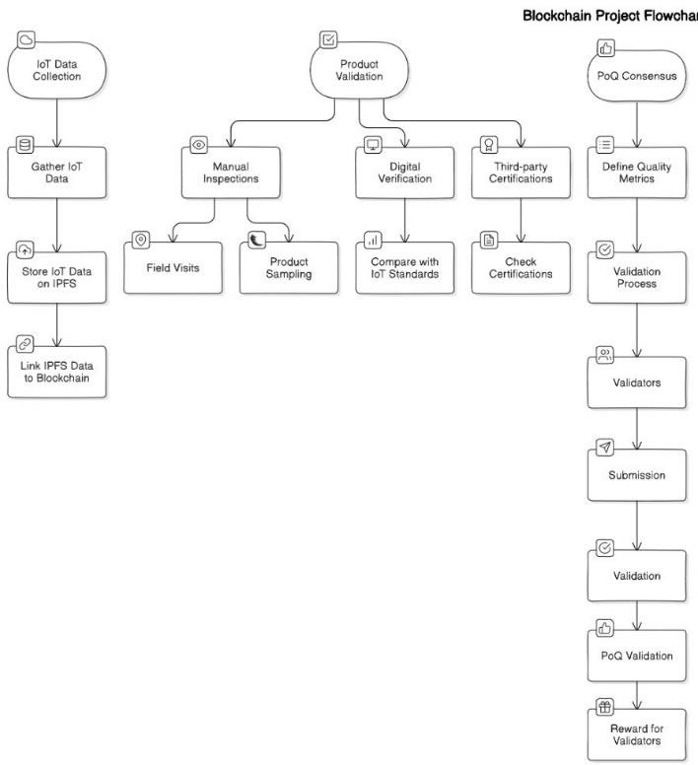

**Figure - 4.1**

**Figure - 4.2**

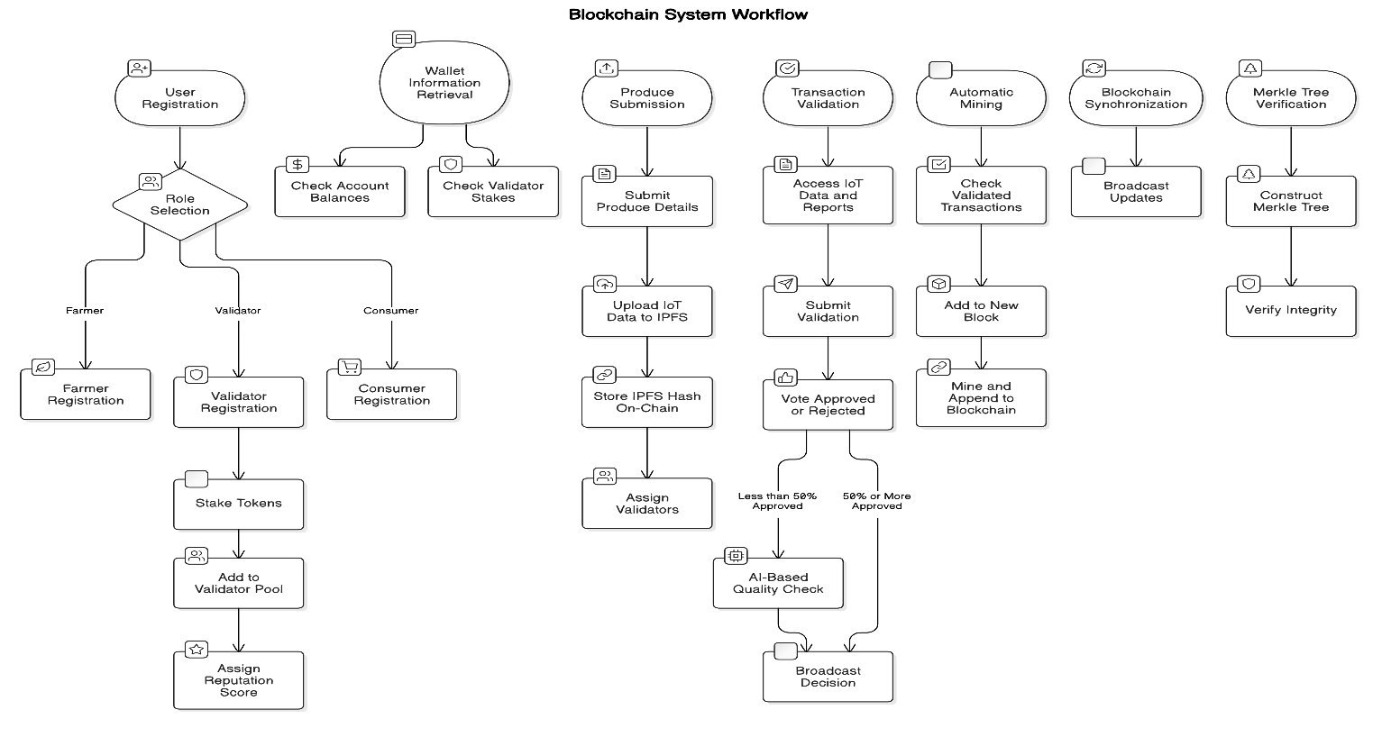

**Figure – 4.3**

# CHAPTER 5 WORKFLOW EXPLANATION

**IoT Data Collection and Blockchain Integration:**

The workflow begins with IoT Data Collection, which forms the foundation of the entire system. IoT devices deployed on farms continuously monitor various parameters, such as soil quality, temperature, humidity, and produce freshness. This data is critical for determining the quality of agricultural products.

Once collected, the IoT data is securely stored on IPFS (InterPlanetary File System). IPFS is a decentralized storage platform that ensures data integrity, accessibility, and

scalability. Unlike traditional databases, IPFS provides distributed storage, preventing single points of failure and ensuring long-term reliability.

After the data is stored on IPFS, it is linked to the blockchain network. The blockchain ensures immutability, meaning the stored data cannot be altered, thus building trust among stakeholders such as farmers, consumers, and regulatory bodies. This integration creates a robust and transparent mechanism for storing and sharing critical agricultural data.

User Registration & Role Selection

* User Registration: A user registers on the platform and selects a role—Farmer, Validator, or Consumer.
* Wallet Information Retrieval: Users can check their account balance or validator stakes before proceeding.

Role-Based Registration

* Farmer Registration: Farmers register to submit their produce for validation.
* Consumer Registration: Consumers register to purchase and verify product authenticity.

Validator Registration:

* Validators stake tokens as a commitment to fair validation.
* They are added to the validator pool.
* A reputation score is assigned based on their validation performance

# Product Validation:

Product validation is a multi-step process that ensures the quality and authenticity of agricultural produce. It is divided into three main components:

Produce Submission

* Farmers submit details about their produce.
* IoT data (such as freshness and quality parameters) is uploaded to IPFS (InterPlanetary File System) for decentralized storage.
* The IPFS hash (a unique reference to the stored data) is recorded on the blockchain.
* Validators are assigned to verify the submission.

1. Manual Inspections:
   * Inspectors conduct field visits to physically examine the farming practices, the state of the crops, and adherence to agricultural guidelines.
   * During the visits, inspectors also perform product sampling by collecting representative samples of produce to test for specific quality metrics such as freshness, size, and nutritional content.
2. Digital Verification:
   * IoT data collected from the farms is compared with predefined IoT standards, ensuring that the produce meets the required quality benchmarks.
   * Additionally, the system supports third-party certifications, where external certification bodies verify the authenticity of the produce. These certifications are vital for establishing consumer trust.

### Third-Party Certifications:

* Certification agencies provide independent verification of farming methods, product quality, and compliance with industry standards. This step further strengthens the credibility of the data stored in the blockchain.

By combining manual inspections, digital verification, and third-party certifications, the system ensures that only high-quality produce is approved for blockchain integration.

# Proof of Quality (PoQ) Consensus Mechanism:

The Proof of Quality (PoQ) consensus is a unique validation mechanism designed to maintain the reliability of the blockchain system. It begins with the definition of quality metrics, which serve as the benchmarks for validating agricultural products. These metrics may include parameters such as freshness, nutritional content, and adherence to organic farming practices.

The validation process involves a network of validators who verify the submitted data against the defined quality metrics. Validators play a crucial role in maintaining the integrity of the blockchain. To incentivize their participation, validators receive rewards for accurate and consistent validation.

Transaction Validation

* Validators access IoT Data & Reports linked to the produce submission.
* They submit their validation decision (Approve/Reject).
* If ≥50% of validators approve, the transaction is accepted.
* If <50% approve, an AI-Based Quality Check is triggered for further verification.
* The decision (approved/rejected) is broadcasted to the network.

The PoQ consensus follows a structured workflow:

1. Validators assess the submitted data.
2. The data is validated through a decentralized process to avoid bias or manipulation.
3. Once the validation is complete, the data is approved for blockchain storage.
4. Validators are rewarded for their efforts, encouraging continued participation and maintaining a high level of accuracy in the system.

This process not only ensures data integrity but also fosters trust among all stakeholders in the agricultural supply chain.

Automatic Mining

* Validated transactions are checked and grouped into a new block.
* The block is mined and appended to the blockchain.

# Incentivizing Validators:

To maintain the accuracy and reliability of the blockchain system, validators are incentivized through two primary mechanisms:

1. Reward Mechanisms:

* Validators with a high rate of accurate validation earn rewards, such as tokens or reputation points.
* The system includes a reputation mechanism, where validators with consistent performance gain credibility, increasing their demand in the ecosystem.

1. Agricultural Cooperatives:

* Cooperatives can place bulk orders with trusted validators, further strengthening the network.
* Validators’ reputations are enhanced through consistent interactions with cooperatives, creating a cycle of trust and reliability.

By incentivizing validators, the system ensures continuous engagement and high- quality data validation.

**Merkle Tree Verification:**

* A Merkle Tree structure is constructed to verify transaction integrity.
* The integrity check ensures that data has not been altered or tampered with.

# CHAPTER 6 ALGORITHM

**Elliptic Curve Digital Signature Algorithm (ECDSA):**

The Elliptic Curve Digital Signature Algorithm (ECDSA) is a widely adopted cryptographic signature scheme, particularly known for its compact size and security at lower computational costs. It utilizes the mathematical properties of elliptic curves over finite fields to produce digital signatures that are used to authenticate transactions and verify the integrity of messages.

In blockchain systems, ECDSA plays a critical role in maintaining security and data authenticity. By applying elliptic curve cryptography, ECDSA ensures that each transaction in the blockchain is signed by the rightful owner and cannot be forged. It uses two keys: a private key to generate the signature, and a public key to verify it. Only the holder of the private key can create a signature, ensuring that the data is not tampered with by unauthorized parties.

In the context of this agricultural blockchain project, ECDSA allows farmers and other supply chain participants to digitally sign IoT sensor data—such as soil moisture levels, crop health, and environmental readings—before submitting it to the blockchain. The signatures are then verified by validators to ensure data authenticity. This cryptographic guarantee of data integrity prevents malicious actors from submitting false or altered information, thereby promoting transparency and trust in the agricultural supply chain. Additionally, the ECDSA algorithm ensures that even with the introduction of IoT sensors in farming, data authenticity can be maintained without compromising system efficiency. As IoT devices proliferate in agricultural environments, having a secure mechanism like ECDSA ensures the system remains scalable and secure.

**Mahalanobis Distance–Based Quality Evaluation:**

The Mahalanobis Distance is a statistical measure that calculates the distance between a data point and a distribution while accounting for correlations among variables. It is defined by the formula:

D² = (x - μ)ᵀ Σ⁻¹ (x - μ)

where:

* **x** represents the farmer’s IoT sensor data vector,
* **μ** is the mean vector derived from validator sample data, and
* **Σ** is the covariance matrix capturing the variances and correlations among the sensor readings.

In our agricultural blockchain project, this metric is critical for comparing the quality of produce by quantifying how far a farmer’s data deviates from the established quality benchmarks. By incorporating the Mahalanobis Distance into our quality check algorithm, we obtain a robust, multidimensional evaluation that accounts for interrelated factors like temperature, humidity, and soil moisture. This distance, when combined with an autoencoder's reconstruction error, produces a comprehensive quality score that determines whether a product is approved, flagged for review, or rejected—ensuring that only premium, verified produce is recorded on the blockchain.

**Autoencoder-Based Anomaly Detection:**

This Blockchain system uses a pretrained autoencoder to assess the quality of IoT sensor data. The autoencoder is trained on “normal” sensor readings so that it learns the inherent patterns and correlations among features (such as temperature, humidity, etc.). When new data is processed, the autoencoder attempts to reconstruct it, and the difference between the original and reconstructed data—quantified as the reconstruction error—serves as a key indicator of anomalies.

Working Principle:

**Model Loading:**

The autoencoder model is loaded using TensorFlow.js (tf.loadLayersModel). This model is pretrained on a dataset of high-quality sensor readings, ensuring it captures the normal operating patterns of agricultural conditions.

**Data Preparation:**

The farmer’s IoT sensor data, provided as a JSON object, is converted into a numeric vector and then into a tensor. This step ensures the data is in the correct format for the autoencoder.

**Reconstruction Process:**

The prepared tensor is passed through the autoencoder, which generates a reconstructed version of the input data. The autoencoder’s goal is to minimize the reconstruction error during its training.

**Error Calculation:**

The mean squared error (MSE) between the original data tensor and the reconstructed tensor is computed. A low reconstruction error suggests that the new data closely resembles the normal pattern, while a high error indicates potential anomalies or quality issues.

**Integration with Overall Quality Score:**

The reconstruction error is combined with the Mahalanobis distance (which measures the statistical deviation of the sensor data from validator benchmarks) using a scaling factor. This combined score determines whether the produce is approved, flagged for review, or rejected.

# Merkle Tree:

A Merkle Tree is a binary tree structure used in cryptography and blockchain technology to efficiently and securely verify the integrity of large sets of data. The Merkle Tree allows data to be summarized and securely represented by a single hash, known as the "Merkle root." This hierarchical structure enables efficient verification of data integrity by reducing the amount of data required for verification.

In the blockchain system, each individual data element, such as an IoT sensor reading or a product certification, is hashed into a leaf node. These hashes are then paired and

recursively hashed to form parent nodes until a single root is obtained. This Merkle root serves as a compact and efficient representation of all the data in a block.

In the agricultural blockchain project, the Merkle Tree is used to securely store and verify IoT sensor readings, quality assessments, and other data points like crop conditions and environmental factors. The advantage of using Merkle Trees is that they allow the system to verify the integrity of any specific data entry without needing to download or examine the entire dataset. A small modification to any data point in the tree would change the root hash, making tampering immediately detectable. This ensures that any unauthorized change to the data would invalidate the entire block, preventing manipulation and ensuring that only reliable, verified data is stored on the blockchain.

Furthermore, the Merkle Tree's structure provides scalability by allowing participants to verify individual data entries efficiently, which is especially important as the number of IoT sensors and data points increases in large-scale agricultural operations.

# Proof of Quality (PoQ):

Proof of Quality (PoQ) is a specialized consensus mechanism tailored for agricultural blockchains. Unlike traditional consensus mechanisms like Proof of Work (PoW), PoQ focuses on verifying and certifying the quality of agricultural products before they are recorded on the blockchain. This ensures that only high-quality, verified products make it to the market and can be traced through the entire supply chain.

In this project, the PoQ mechanism uses data from IoT sensors, such as soil pH, nutrient levels, and temperature, to evaluate the quality of agricultural products. These sensors provide real-time data about the crops, which are then analyzed against predefined quality standards. If the product meets the established benchmarks, it is certified and recorded on the blockchain, guaranteeing that only quality products are available for consumers.

By introducing PoQ, the blockchain provides a transparent and traceable certification system for agricultural goods. Consumers can confidently verify the origin and quality of the products they purchase. Additionally, PoQ incentivizes farmers to adhere to quality standards and ensures that only products meeting these standards are transacted, thus elevating the value of agricultural goods.

PoQ also helps create a more efficient supply chain by minimizing wastage and ensuring that only viable, certified products are transported and sold. This is particularly valuable

in agriculture, where perishable goods are often subject to fluctuating quality conditions.

# Proof of Work (PoW):

Proof of Work (PoW) is a widely known consensus algorithm used in blockchain systems to secure the network and ensure data integrity. PoW requires participants (known as miners or validators) to perform computationally expensive tasks in order to verify transactions and add new blocks to the blockchain. The process is resource- intensive, but it plays a key role in ensuring the immutability of the blockchain, preventing unauthorized modifications to past transactions.

In the agricultural blockchain project, PoW is implemented in a simplified form to ensure that every block of data added to the blockchain is validated through a computationally verifiable process. This guarantees that malicious actors cannot easily alter past transactions or add fraudulent data to the blockchain.

While PoW can be resource-intensive, its role in securing the blockchain ensures that once data is recorded, it cannot be altered retroactively. This provides a high level of confidence in the integrity of the supply chain data, such as product certifications, farm conditions, and IoT sensor readings. This immutability makes it extremely difficult for any party to tamper with the data without expending significant computational resources.

By simplifying the PoW process for this project, we prioritize supply chain transparency while maintaining a reasonable level of computational effort to secure the data and prevent manipulation.

# SHA-256 Hashing:

SHA-256 (Secure Hash Algorithm 256-bit) is a cryptographic hash function that takes an input and produces a fixed-size output (256 bits, or 32 bytes). The output, known as a "hash," is a unique representation of the input data, and even a slight change in the input results in a completely different hash. This property makes SHA-256 an ideal tool for ensuring the integrity of data in a blockchain.

In the agricultural blockchain project, SHA-256 is used in several critical areas. First, it is used in the Merkle Tree to hash IoT sensor readings and product quality data, ensuring that any modification to the data is easily detectable. Each block in the blockchain

contains a SHA-256 hash of the previous block, which links the blocks together in a chain, further securing the blockchain and preventing tampering.

Moreover, SHA-256 is applied in the PoW consensus algorithm to secure transactions. The process of miners solving computational tasks involves hashing the block's data to find a valid hash that meets the required difficulty level. This prevents malicious actors from easily modifying the blockchain's history and ensures the authenticity of all recorded transactions.

The use of SHA-256 provides the necessary cryptographic security to ensure that all transactions and data stored in the blockchain are tamper-proof and trustworthy. This is particularly important in agriculture, where the integrity of data directly impacts consumer confidence and the value of products.

# Peer-to-Peer (P2P) Network:

The Peer-to-Peer (P2P) Network is the backbone of a decentralized blockchain system. In a P2P network, every participant (node) has an equal say in validating transactions and maintaining a copy of the blockchain. This decentralized architecture eliminates the need for a central authority, allowing for more transparent, trustless interactions between participants.

In the context of the agricultural blockchain, the P2P network ensures that all stakeholders, including farmers, transporters, validators, and consumers, have equal access to the blockchain's data. Each participant has a full or partial copy of the blockchain and is responsible for validating transactions. This decentralized structure ensures that no single entity can control or manipulate the system, fostering trust and reliability throughout the agricultural supply chain.

Transactions, such as the submission of IoT sensor data or product certifications, are broadcast across the P2P network. Each participant independently verifies the data before adding it to their own copy of the blockchain. Once consensus is reached, the transaction is added to the blockchain and becomes immutable.

The P2P network also increases the system's resilience. If one node goes offline or is compromised, the rest of the network can continue to function normally.

# CHAPTER 7 COST ESTIMATION

|  |  |  |
| --- | --- | --- |
| **Cost Component** | **Our CustomBlockchain** | **IBM Blockchain** |
| **Blockchain Development** | **₹5.0** | **₹8.0** |
| **Validator Fees** | **₹1** | **₹1.5** |
| **Transaction Fees** | **₹0.5** | **₹1** |
| **Peer-to-Peer Server & Network Setup** | **₹1.5** | **₹3.0** |
| **Consensus Optimization** | **₹0.5** | **₹1.0** |
| **State Synchronization & Maintenance** | **₹0.5** | **₹1.5** |
| **Digital Signature & Cryptography** | **₹0.5** | **₹1.0** |
| **Total Blockchain Cost** | **₹9.5** | **₹17.0** |

Table 7.1

**Cost Comparison: Custom Blockchain vs. IBM Blockchain**

The cost comparison between our custom blockchain and the IBM blockchain reveals the substantial cost benefits of using a customized blockchain solution. By creating a blockchain specifically designed for agricultural supply chains, we have been able to save costs by around 44%, rendering it a more efficient and cost-effective option.

Our proprietary blockchain does this cost savings through reducing validator fees, optimizing consensus processes, and employing effective cryptographic security. As opposed to IBM's blockchain that incurs increased infrastructure and maintenance expenses, our method utilizes light-weight, peer-to-peer network design that provides data synchronization with fewer operational costs.

Moreover, our system's lower transaction fees and validator costs enable farmers and supply chain participants to adopt blockchain, thereby promoting higher levels of transparency and trust in the ag market. This efficient cost model not only guarantees equitable pricing, but also reinforces supply chain data integrity, with blockchain technology thus proving to be **a sustainable and scalable solution for agriculture.

**CHAPTER 8**

# Architecture Diagram

Figure – 8.1

# CHAPTER 9 OUTPUT SCREENSHOT

Farmer HomePage - Dashboard

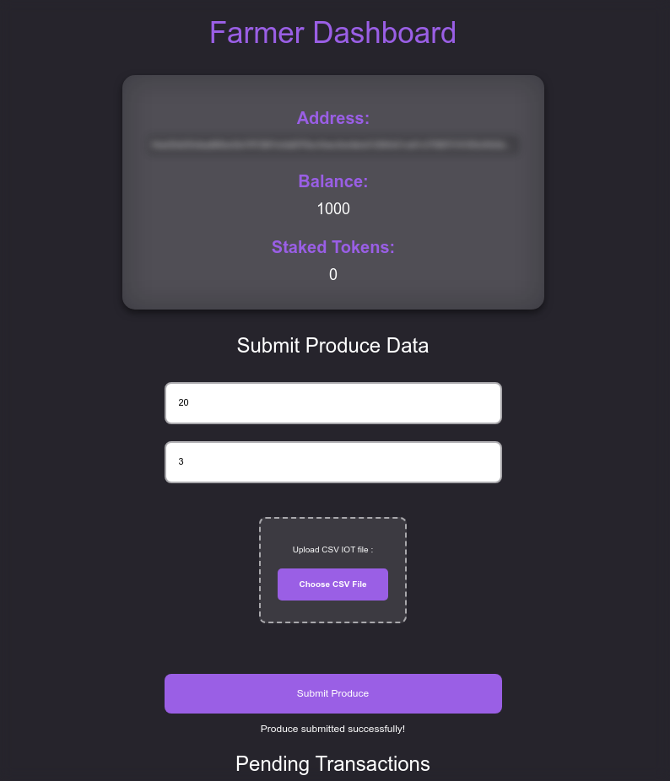

Figure – 9.1

**Farmer Dashboard - Submit Produce**

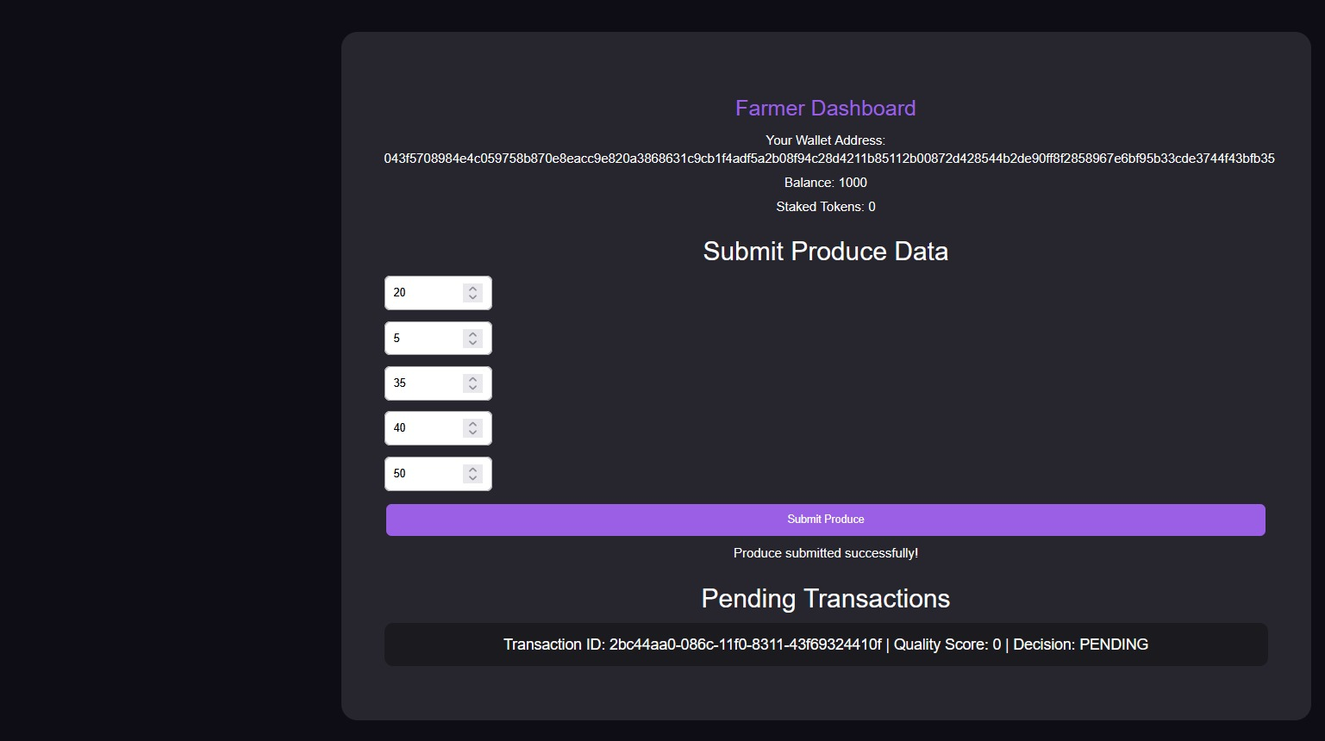

Figure – 9.2

Validator Dashboard

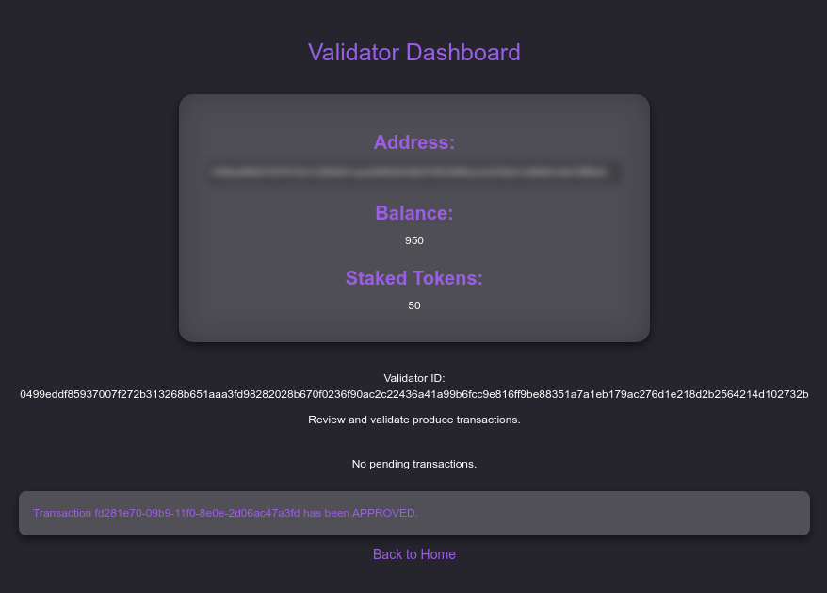

Figure - 9.3

**Transaction For Validator Page**

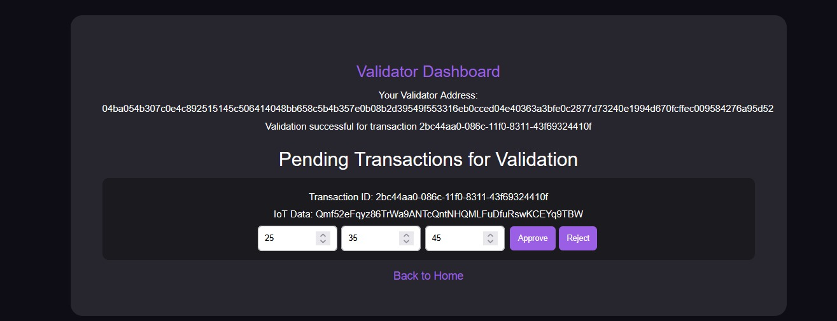

Figure – 9.4

**Blocks Page** 

Figure – 9.5

# Blockchain DashBoard

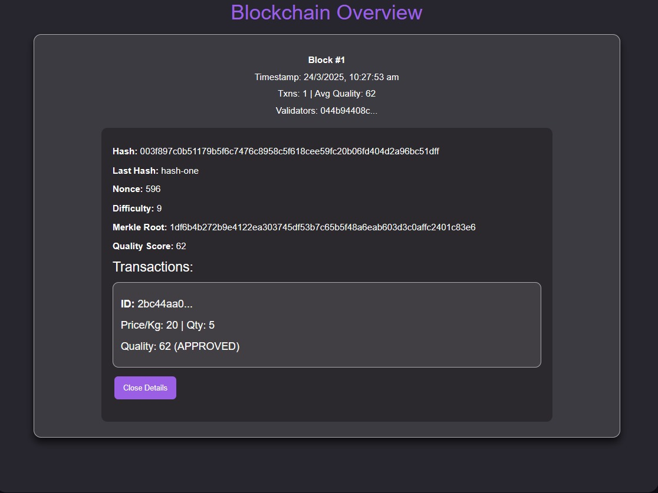

Figure – 9.6

# Merkle Tree

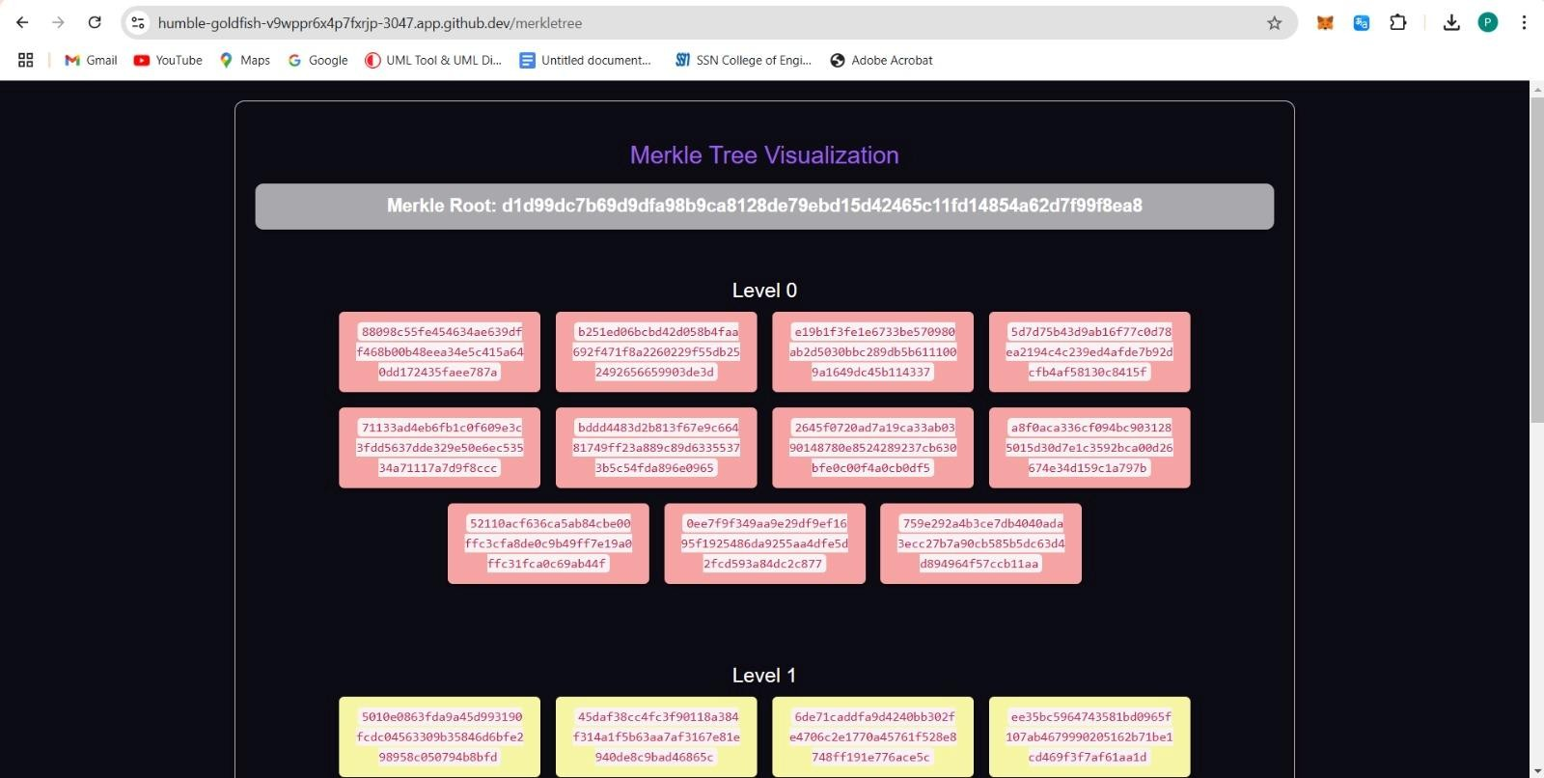

Figure – 9.7

# CHAPTER 10

**SOCIAL IMPACT AND SUSTAINABILITY**

The blockchain-based agricultural supply chain project has the potential to significantly improve social equity and promote sustainability in agriculture. By removing intermediaries and establishing direct farmer-to-consumer transactions, the project ensures fair pricing, enabling farmers—particularly small-scale and independent ones—to receive a larger share of profits. This economic empowerment is further bolstered by real-time access to market trends, allowing farmers to make informed decisions about crop selection, production, and pricing strategies. The project’s Proof of Quality (PoQ) consensus mechanism incentivizes sustainable farming practices by rewarding high-quality produce, encouraging the adoption of environmentally friendly methods such as organic farming and reduced pesticide usage.

For consumers, the project enhances trust and confidence in the food supply chain. Through QR code integration, buyers can access comprehensive product details, including origin, quality checks, and freshness, ensuring transparency and quality assurance. This traceability not only builds consumer trust but also promotes sustainable purchasing behaviors. By leveraging IoT sensor data, the system ensures efficient monitoring of environmental conditions like soil health and weather patterns, enabling farmers to optimize resource usage, reduce waste, and implement data-driven, sustainable agricultural practices.

The project's implementation also fosters economic development in rural areas by creating new job opportunities in roles such as IoT data management, blockchain development, and product validation. Investments in infrastructure, such as cold storage facilities and quality inspection mechanisms, further enhance rural development. Moreover, the platform’s decentralized and inclusive design helps reduce inequalities by providing smaller farmers access to advanced technologies and larger markets, fostering equitable growth across the supply chain.

From an environmental perspective, the project contributes to sustainability by reducing waste, lowering carbon emissions through efficient supply chain operations, and promoting biodiversity through sustainable farming practices. By minimizing transportation inefficiencies and prioritizing local sourcing, the system reduces the agricultural sector's carbon footprint. Additionally, the emphasis on resource-efficient farming helps preserve soil health and water quality, contributing to long-term environmental preservation.

This project aligns with global sustainability efforts, including the United Nations Sustainable Development Goals (SDGs), such as No Poverty, Zero Hunger, Responsible Consumption and Production, and Climate Action.

# CHAPTER 11 CONCLUSION

Our blockchain-based agricultural supply chain system represents a groundbreaking step toward modernizing the agricultural industry by addressing critical challenges such as transparency, security, and trust. By integrating advanced cryptographic techniques like ECDSA for digital signatures, Merkle Trees for data verification, and SHA-256 for secure hashing, we ensure the integrity and authenticity of all transactions and records stored on the blockchain. This immutability instills confidence among stakeholders, from farmers to consumers, creating a system where data is both reliable and tamper- proof.

The Proof of Quality (PoQ) mechanism is a unique feature of this system, specifically designed to meet the quality assurance needs of the agricultural sector. Leveraging real- time data from IoT sensors, PoQ allows for the certification of agricultural products based on critical parameters such as freshness, nutrient content, and environmental conditions. This capability not only enhances consumer trust but also enables farmers to command better prices for high-quality produce.

The system also incorporates the Proof of Work (PoW) algorithm, providing a simple yet effective method to maintain consensus across the network, ensuring consistent and reliable operations. Furthermore, the Peer-to-Peer (P2P) network architecture decentralizes control, eliminating reliance on a central authority and making the system more resilient and equitable. By decentralizing data storage and management, this architecture empowers farmers while ensuring that consumers receive products that meet their expectations for quality and traceability.

In essence, this project showcases the immense potential of blockchain technology to address the specific needs of the agricultural supply chain. It demonstrates how emerging technologies can be tailored to create a transparent, efficient, and farmer- centric ecosystem. By bridging the gap between producers and consumers, fostering fairness, and ensuring quality at every step, this system paves the way for a sustainable and innovative future in agriculture. The success of this project underscores the transformative power of blockchain and its ability to drive progress in critical sectors like agriculture.

**CHAPTER 12**

### REFERENCES

1. Agriculture Supply Chain Management Based on Blockchain Architecture and Smart Contracts- Adil El Mane; Volume 2022, Article ID 8011525, <https://onlinelibrary.wiley.com/doi/epdf/10.1155/2022/8011525>
2. AGRICULTURE ON THE BLOCKCHAIN Sustainable Solutions for Food, Farmers, and Financing Henry Kim and Marek Laskowski York University December 2017
3. Applying Blockchain in Agriculture: A Study on Blockchain Technology, Benefits, and Challenges January 2021;DOI: [10.1007/978-3-030-60265-9_11](http://dx.doi.org/10.1007/978-3-030-60265-9_11) Sandeep Kumar M,Maheshwari Venkat
4. , Blockchain Technology for Agriculture: Applications and Rationale; Hang Xiong1*Tobias Dalhaus2Puqing Wang3Jiajin Huang4,5
5. , Blockchain and agricultural supply chains traceability: research trends and future challenges**;** panelGiovanni Mirabelli a, Vittorio Solina-2020
6. Exploring the role of blockchain technology in modern high-value food supply chains: global trends and future research directions; Giulia Chiaraluce, Deborah BentivogJj@**-**2019
7. S. Viriyasitavat, and A. Hoonsopon, “Blockchain in the Supply Chain Management: A Review and Research Framework,” Logistics, vol. 3, no. 1, pp. 1-20, 2019.
8. H. Lin, and N. Zhu, “Exploring the Potential of Blockchain in Agriculture: A Literature Review,” Journal of Agricultural Studies, vol. 6, no. 2, pp. 48-60, 2018.
9. khaled salah, nishara nizamuddin, raja jayaraman, and mohammad omar, “Blockchain- Based Soybean Traceability in Agricultural SupplyChain”, IEEE Access Volume 7- 2019, DOI10.1109/ACCESS.2019.2918000.
10. Fran Casinoa, Venetis Kanakarisb, Thomas K. Dasaklisa, Socrates Moschurisc, Spiros Stachtiarisc, “Blockchain-based food supply chain traceability: a case study in the dairy sector”, International journal of production research – 2020.
11. Mohammad Hossein Ronaghi, “A blockchain maturity model in agricultural supply chain”, Information processing in agriculture 8 (2021) 398– 408.
12. shuchih e. chang and yichian chen , “When Blockchain Meets Supply Chain: A Systematic Literature Review on Current Development and Potential Applications”, IEEE Access -2020, DOI 10.1109/ACCESS.2020.2983601.
13. Vineet Paliwal, Shalini Chandra and Suneel Sharma , “Blockchain Technology for Sustainable Supply Chain Management: A Systematic Literature Review and a Classification Framework”, Sustainability 2020, 12, 7638, DOI 10.3390/su12187638.
14. Youness Tribis1, Abdelali El Bouchti, Houssine Bouayad, “Supply Chain Management based on Blockchain: A Systematic Mapping Study”, MATEC Web of Conferences 200, 00020 (2018) IWTSCE’18.
15. huilin chen, zheyi chen , feiting lin1, peifen zhuang, “Effective Management for Blockchain-Based Agri-Food Supply Chains Using Deep Reinforcement Learning”, IEEE Access Volume 9 -2021, DOI 10.1109/ACCESS.2021.3062410
16. Giovanni Mirabelli, “Blockchain and agricultural supply chains traceability: research Trends and future challenges”, ELSEVIER, Procedia Manufacturing 414–42142, DOI 10.3390/info11010021.
17. Caro MP, Ali MS, Vecchio M, Giaffreda R, “Blockchain-based traceability in AgriFood supply chain management: a practical implementation”, In: IoT Vertical and Topical Summit on Agriculture: Tuscany, Italy, p.1-4, DOI 10.1109